**Assignment -1**

**Flask Assignment**

|  |  |
| --- | --- |
| Assignment Date |  |
| Student Name |  |
| Student Roll Number |  |
| Maximum Marks | 2 Marks |

1. Create registration page in html with username, email and phone number and by using POST method display it in next html page.

**register.html**

<html>

<head>

<title>Registration Page </title>

</head>

<body>

<form action="http://127.0.0.1:5000//register" method="POST">

<h1> Registration Form </h1>

<p> Enter your name : <input type="text" name="name"/></p>

<p> Enter your mail id: <input type="email" name="mail"/></p>

<p> Enter your phone number:<input type="number" name="phone"/></p>

<p> <input type="submit" value="submit"></p>

</form>

</body>

</html>

**app.py**

from flask import Flask,redirect,url_for,request

app=Flask(__name__)

@app.route('/success/<string:name>/<string:mail>/<string:phone>')

def success(name,mail,phone):

return "Name: " + name +" <br> Mail ID: "+mail+" <br> Phone number: "+phone

@app.route('/register',methods=['POST'])

def register():

if request.method=='POST':

user=request.form['name']

mailid=request.form['mail']

phonum=request.form['phone']

return redirect(url_for('success',name=user,mail=mailid,phone=phonum))

if __name__=='__main__':

app.run(debug=True)

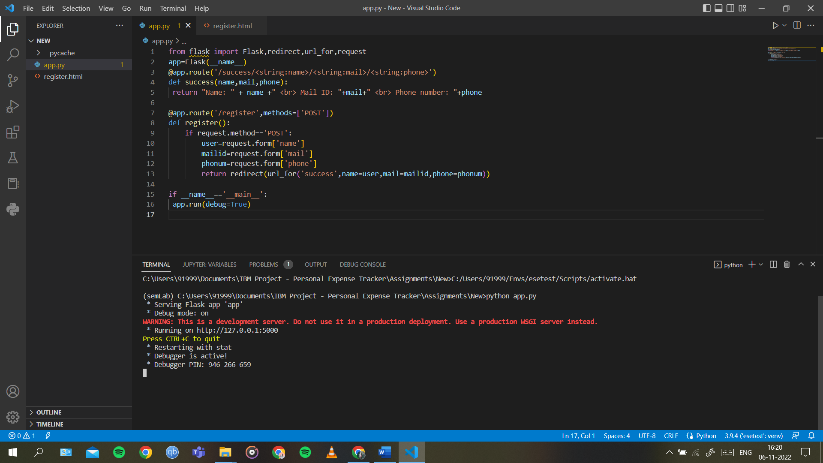

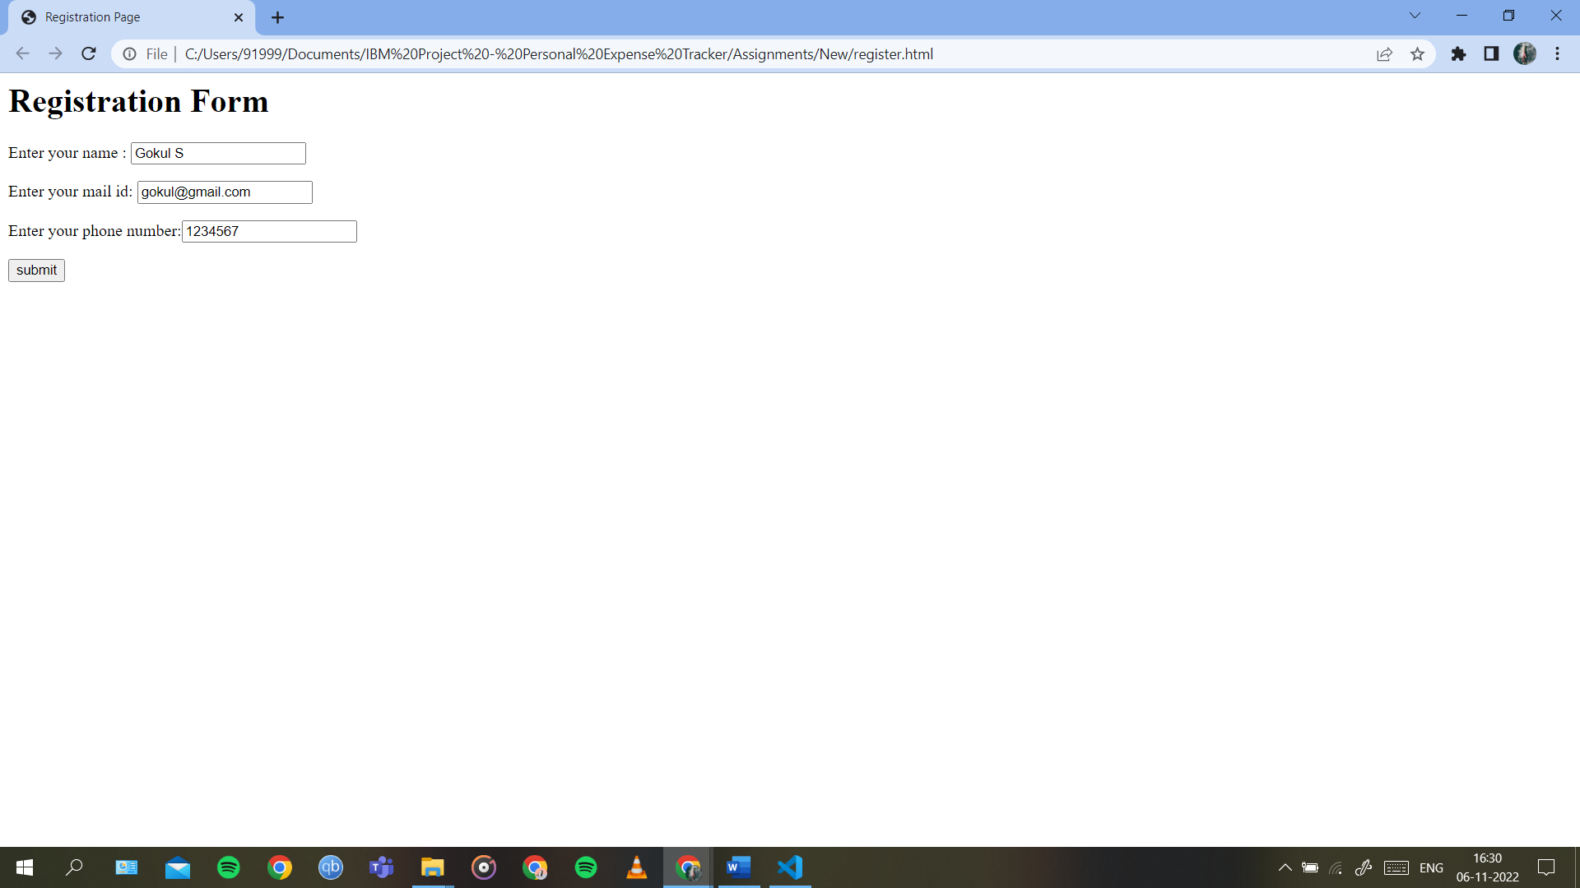

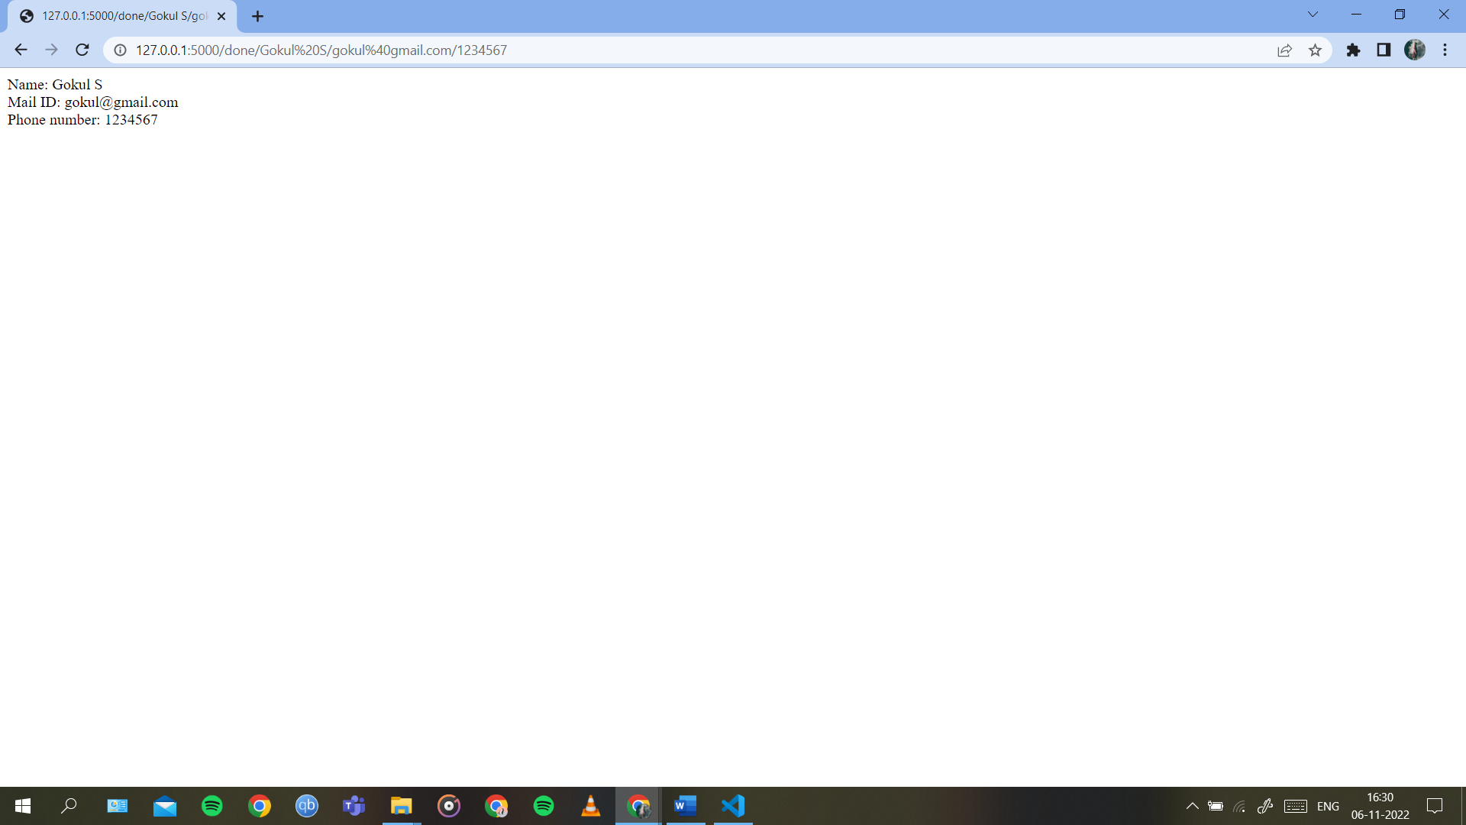

1. Develop a flask program which should contain at least 5 packages used from pypi.org.

from flask import Flask, request, json

app = Flask(__name__)

student_marks = {"Gokul": 94, "Raam": 95, "Ashok": 95, "Serjeel": 99}

@app.route("/mark/<id>", methods=['PUT'])

def Op_update(id):

mark = request.form['student']

student_marks[str(id)] = mark

return 'Mark is Updated'

@app.route("/mark/<id>", methods=["DELETE"])

def Op_delete(id):

student_marks.pop(str(id))

return 'Record Deleted'

@app.route('/mark', methods=['GET', 'POST'])

def api():

if request.method == 'GET':

return student_marks

if request.method == 'POST':

mark = request.json

student_marks.update(mark)

return ' Student Record Inserted'

if __name__ == '__main__':

app.run(debug=True)